**Q1:** What you think this system would do?

**Answer:**

This system provides a way to make different packages for the retailers. There are four variables which help in achieving this:

1. Customer
2. Widget
3. Packaging
4. Price

**Q2:** What you feel would be a reasonable database structure for the data and a reasonable architecture for the system

**Answer:**

1. **Database Structure**

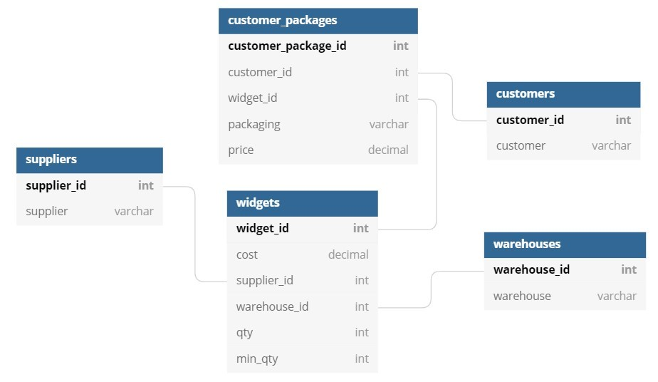

1. **System Architecture**

Backend and Frontend Servers are required here. The backend will be simply used to create the API and database CRUD operations while the frontend servers are required to build the UI/UX to create different packages.

**Q3:** Any questions or concerns you have regarding this dataset/system that might need to be answered before establishing an ideal database/solution for such a system?

**Answer:**

Regarding the system I would want to know exactly what kind of system is desired and how it meets our business needs. Do we need to track inventory? Automate invoicing? Something else?

A couple of questions need to be answered. Below are the points:

1. Invoice Automation
2. Audit logs
3. Tracking where the inventory is going

Will we require to add more features to this system or not?